29/03/2013

**Sprint 1 - Version 0.5.1**

**IUNotifier Application**

**Project Note**

Contents

**I.** **Release Note** 3

1. Login use case 3

2. Logout use case 3

3. Reading News use case 4

4. Getting Events information use case 5

5. Push Notification use case 6

**II.** **Development Note** 7

1. Class Diagram 7

2. Sequence Diagrams 8

2.1. Reading News sequence diagram 8

2.2. Getting Events Information sequence diagram 8

3. Sample Java source 9

3.1. MainMenuActivity class 9

4. Sample Java test source 11

4.1. LoginActivityTest class 11

# **Release Note**

## Login use case

|  |  |
| --- | --- |
| Name | UC-1: Login |
| Summary | Allow the user to use services corresponding to each type of user. |
| Rationale | The IUNotifer application has many types of user and each of them intend to use the app for different purposes. For example, each student in the IU study many courses at a time and each of them may have different major. It would be easier for the student to use the app if each of them has an account when using the application. By using account to login, the application could be able to recognize which student is using and to provide the courses that the student is studying. |
| Users | All users |
| Preconditions | * The device must have internet connection. * The user installed the IUNotifier application. |
| Basic course of events | 1. The user indicates that the application is to provide the login function. 2. The application responses by requesting the user to tap the “Login” icon on the action bar. 3. The user taps the “Login” icon. 4. The application responses by showing the login form and requesting the user to provide the username and password and tap the “Sign in” button. 5. The user fills in the username, password fields and tap the “Sign in” button and indicates that he/she would be able to the app with his/her account already logged in. 6. The application responses by showing the user main menu of the application with the “logged in” icon on the action bar. |
| Alternative paths | 1. In step 5, the user may provide the incorrect username and/or password. In this case, the application responses by showing the “incorrect username/password” message and request the user to provide those filed again. 2. The user may decide to return back to previous screen at any time during steps 4, 5, or 6. |
| Postconditions | The user login successfully. |

## Logout use case

|  |  |
| --- | --- |
| Name | UC-2: Logout |
| Summary | Allow the user to stop using services of a specific type of user. |
| Rationale | It maybe that there are more than 1 people using the same device and it would be reasonable to let a user logout his/her account for the other user to login with his/her account to user the application. |
| Users | All users. |
| Preconditions | * The device must have internet connection. * The user installed the IUNotifier application. |
| Basic course of events | 1. The user indicates that the application is to provide a logout function. 2. The application responses by requesting the user to tap on the “log out” icon on the action bar. 3. The user taps on the “log out” icon and indicates that he/she would successfully log out. 4. The application responses by changing the “log out” icon on the action bar to the “log in” icon. |
| Alternative paths |  |
| Postconditions | The user successfully logout. |

## Reading News use case

|  |  |
| --- | --- |
| Name | UC-3: Reading News |
| Summary | Allow the user to stay up to date with latest news from the IU. |
| Rationale | HCMIU has the advanced and sophisticated network, which is the main channel providing information for students. However, HCMIU network has a lot of websites like IUPortal and Edusoft, plus other websites for each departments, so checking news is time consuming. The News function allows users to be up-to-date with all kinds of news just in a single place and forget about having to browsing from site to site. |
| Users | All users |
| Preconditions | * The device must have internet connection. * The user installed the IUNotifier application. |
| Basic course of events | 1. The user indicates that the application is to provide a reading-news function to read all the news about the IU. 2. The application responses by requesting the user to touch the “News” icon in the main menu of the application. 3. The user taps the “News” icon and indicates that he/she will see a list of news. 4. The application responses by displaying the news list and requests the user to select a news. 5. The user selects a news title and indicates to see the content of the news. 6. The application responses by display the content of the selected news. |
| Alternative paths | 1. In step 1, the user indicates that he/she could be able to get into the application to see the list of news by touching the notifications about the news in the notification system tray. In this case, the news list is displayed and the user can select a news to read. 2. In step 4, the user indicate that he/she can get the latest news by touching the “Refresh” button in the action bar. In this case, all the new news will be loaded and displayed in the news list and the user can select a news from the list to read. 3. The user may decide to return to previous screen at any time during Steps 2, 3, 4, 5, or 6. |
| Postconditions | The user could be able to read the content of a specific news. |

## Getting Events information use case

|  |  |
| --- | --- |
| Name | UC-4: Getting Events information |
| Summary | Keep track of the events of the IU. |
| Rationale | The International University has a lot of events monthly and it’s really hard to remember all them. By using the events feature of the IUNotifier application, the user can keep track of all the interesting events so that he/she will not miss any events. |
| Users | All users |
| Preconditions | * The device must have internet connection. * The user installed the IUNotifier application. |
| Basic course of events | 1. The user indicates that the application is to provide all the information about the events of the International University. 2. The application responses by requesting the user to touch the “Events” icon in the main menu of the application. 3. The user touches the “Events” icon and indicate that he/she will see a list of events. 4. The application responses by showing a list of events and requests the user to select an event. 5. The user chooses a specific event and indicate that he/she will see all the information of the event. 6. The application responses by displaying all information related to the selected event. |
| Alternative paths | 1. In step 1, the user indicates that he/she could be able to get into the application to see the list of events by touching the notifications about the events in the notification system tray. In this case, the events list is displayed and the user can select an event to get the information. 2. In step 3, the user can choose to view all the events are held on that day by touching the “Today” Upcoming” button. After touching the each button, the corresponding event list will be displayed on the screen. After that, the user can choose an event to get the specific information. 3. In step 3, the user can choose to view all the upcoming events by touching the “Upcoming” button and the corresponding event list will be displayed on the screen. After that, the user can choose an event to get the specific information. 4. In step 3, the user can choose to view all the events by touching the “All” button and the corresponding event list will be displayed on the screen. After that, the user can choose an event to get the specific information. 5. In step 6, the user can choose to add the event information to the phone’s calendar by touching the “Add to calendar” button. 6. The user may decide to return back to the previous screen at any time during Steps 2, 3, 4, 5, or 6. |
| Postconditions | The user get all information about a specific event of the IU. |

## Receive Push Notification use case

|  |  |
| --- | --- |
| Name | UC-3: Receive Push Notification |
| Summary | Show all the updates from news and events of the IU. |
| Rationale | The International University usually have new news and events updated on the websites where everybody cannot visit all the time. The push notification allows the user to be announced immediately whenever there is any new news or events updated on the websites regardless of the location of the user. |
| Users | All users |
| Preconditions | * The device must have internet connection. * The user installed the IUNotifier application. * The user subscribed to the news and events channels. |
| Basic course of events | 1. The user indicates that he/she should be notified about any new news and events of the IU. 2. The application responses by showing notification(s) whenever there is any new news and/or events of the IU. |
| Alternative paths | 1. On step 2, the user indicates that he/she should be able to tap on the notification about the news to see the updated news. In this case, the application responses by showing the list of news when the user tap on the notification. 2. On step 2, the user indicates that he/she should be able to tap on the notification about the events to see the updated events. In this case, the application responses by showing the list of events when the user tap on the notification. |
| Postconditions | The user is announced about any new news or events of the IU by the appearance of the notifications. |

# **Development Note**

## Class Diagram

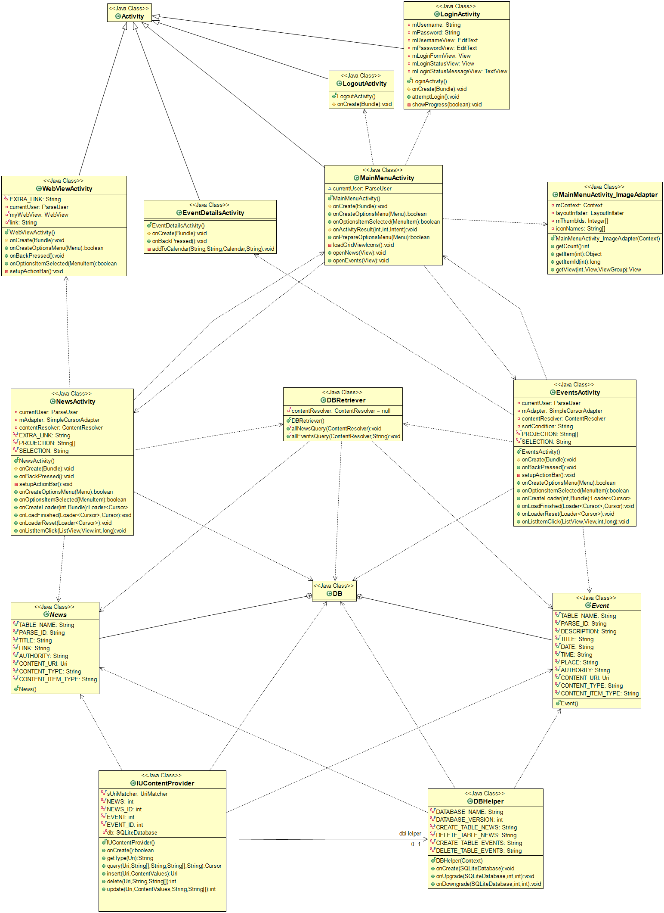

## Sequence Diagrams

### Reading News sequence diagram

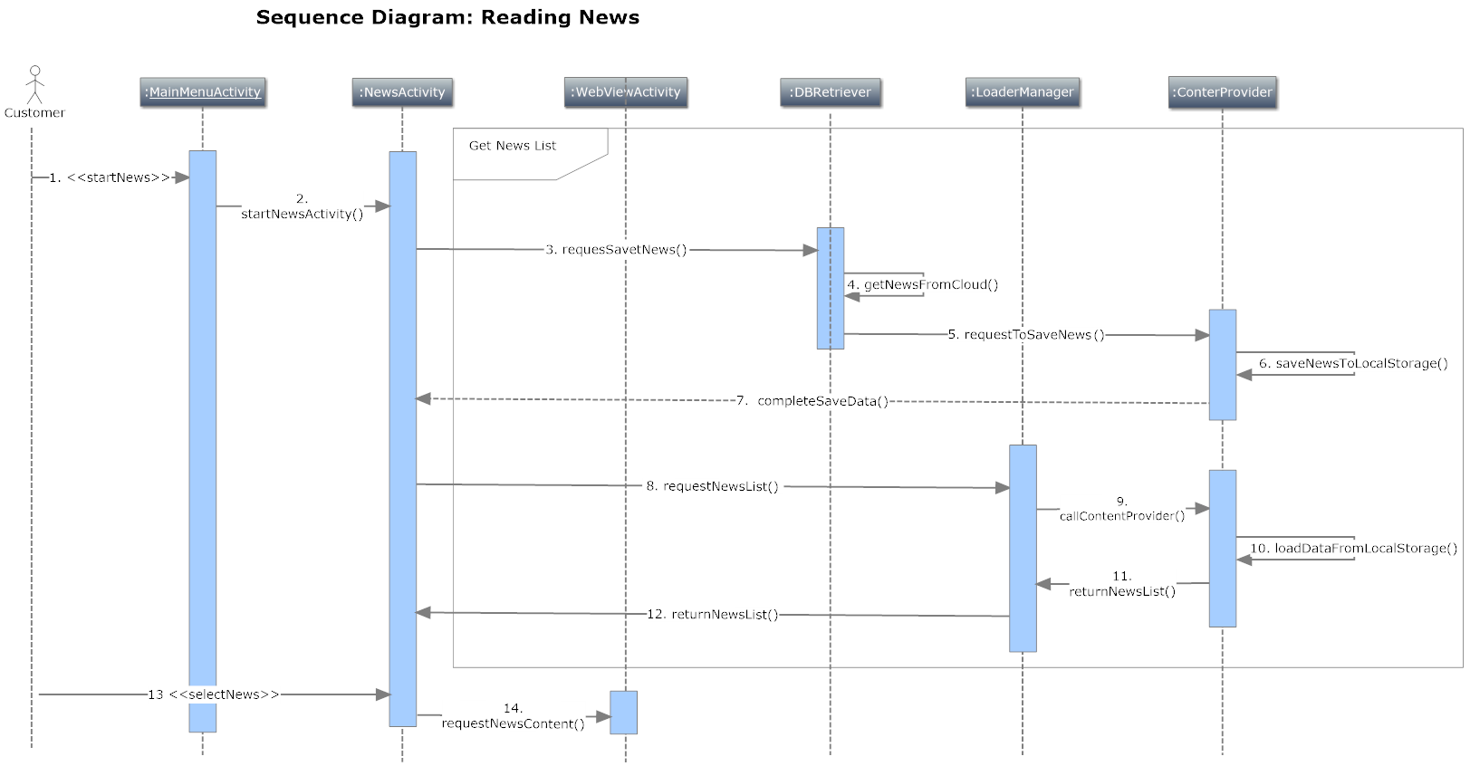

### C:\Users\xmen458\Documents\SmartDraw\IUNotifier Diagrams\Getting Events Info Sequence Diagram.pngGetting Events Information sequence diagram

## Sample Java source

### MainMenuActivity class

#### Class Structure

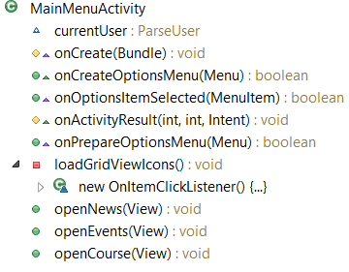

#### Class source code

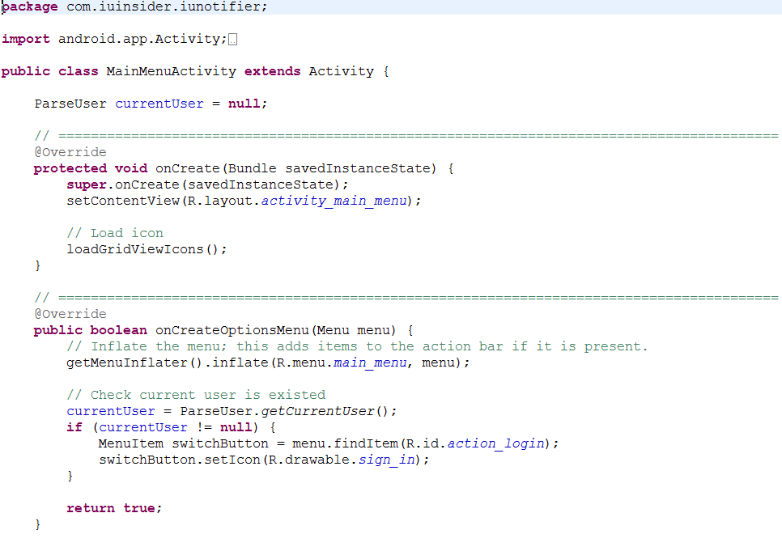

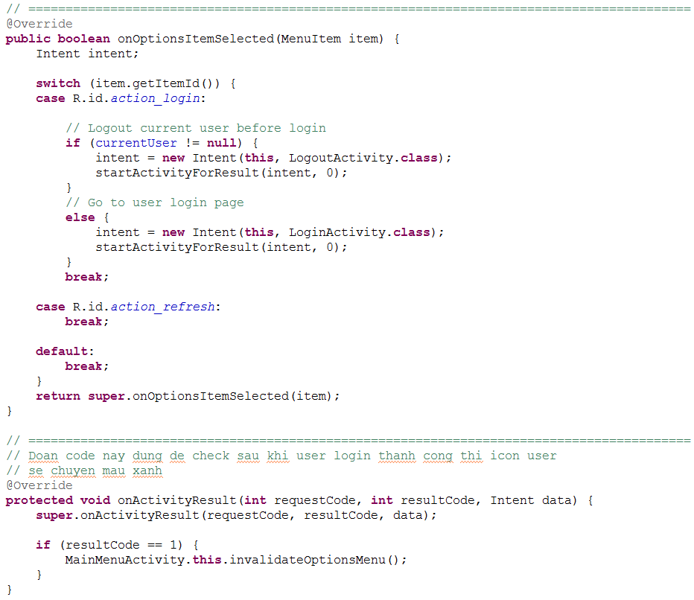

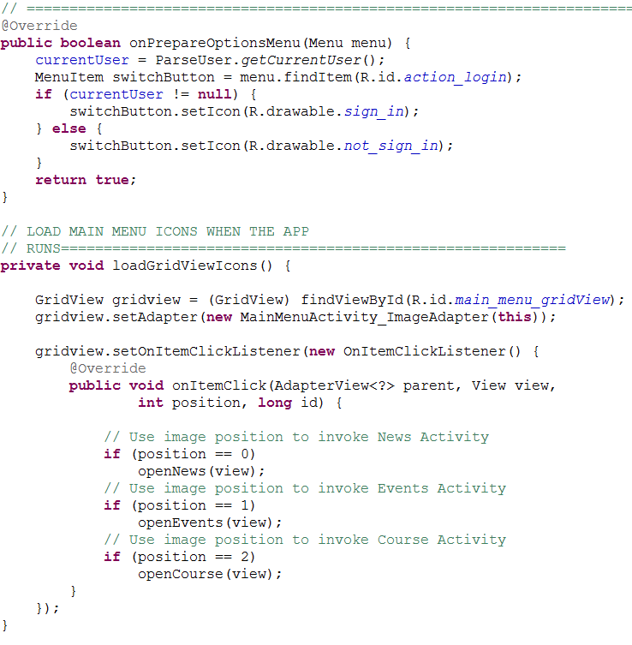

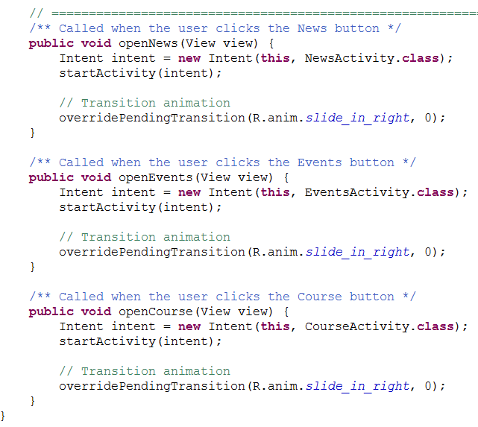

## Sample Java test source

### LoginActivityTest class

#### Class structure

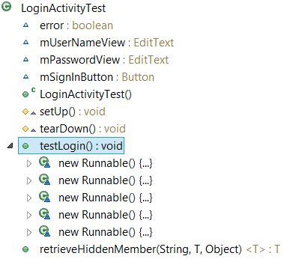

#### Class source code

